1. **Agenda:** With those basics about the data, the documents and how we work with data out of the way, let’s shift our focus towards the CRUD Operations and how we work with the different CRUD Operations.
2. **Why do CRUD Operations matter?**
3. You can use mongodb for a broad variety of things.
   1. You might use it for building app.
   2. You may have some data shipped to you as a single file and you want to run some analytics on it.
   3. You’re administrator of mongodb database.
4. So, you have to interact with the databases.
5. 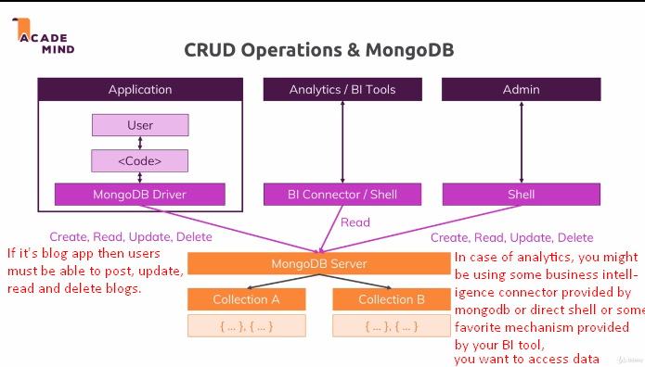  
   Admin also needs to access data to delete, update etc.
6. 